Predicting Laptop Prices
A hands-on case study guiding you through building a laptop price prediction model using real-world data. You'll learn to load, clean, and engineer features from a dataset, perform exploratory analysis, encode categorical variables, build a regression model, and interpret its results.

Data Loading and Initial Inspection
The Predicting Laptop Prices Using Feature Engineering project focuses on building a machine learning model to predict laptop prices based on hardware specifications. Before applying regression algorithms, the dataset requires significant feature extraction.
Real-world data is rarely perfect. Many numeric features in the provided dataset (such as RAM size, SSD capacity, or OS bit size) are stored as text with units (e.g., "4 GB" instead of just 4). The initial objective is to parse these strings and convert them into numerical formats suitable for machine learning models.
The dataset laptop_price.csv contains the following columns:
Column | Description
brand | Laptop brand (ASUS, Lenovo, HP, etc.)
processor_brand | Processor manufacturer (Intel, AMD)
processor_name | Processor model (Core i3, Ryzen 9, etc.)
processor_gnrtn | Processor generation (e.g., "10th")
ram_gb | RAM capacity (text, e.g., "4 GB")
ram_type | RAM type (DDR4, LPDDR4X)
ssd | SSD capacity (text, e.g., "512 GB")
hdd | HDD capacity (text, e.g., "1024 GB")
os | Operating system (Windows, DOS, Mac)
os_bit | OS bit size (text, e.g., "64-bit")
graphic_card_gb | Graphics card memory (text, e.g., "2 GB")
weight | Laptop weight category (Casual, ThinNLight)
warranty | Warranty period
Touchscreen | Touchscreen availability (Yes / No)
msoffice | Pre-installed MS Office (Yes / No)
Price | Laptop price (target variable)
rating | User rating (text, e.g., "3 stars")
Number of Ratings | Total number of ratings
Number of Reviews | Total number of text reviews
The first step in any data science pipeline involves loading the data and inspecting its structure. Using the .info() method reveals that many columns expected to be numeric are currently classified as object (string) types.
Task
Load and inspect the laptop dataset:
- Import the pandas library as pd.
- Load the dataset 'laptop_price.csv' into a DataFrame named df.
- Print the first 5 rows of the DataFrame using .head().
- Inspect the data types and non-null counts by calling the .info() method on df.

Extracting Memory and Storage Features
Numeric features such as memory capacity are stored as strings containing units (for example, "4 GB"). For a machine learning model to utilize these features, they must be converted into standard numerical values.
The .str.replace() method enables the removal of specific substrings (such as " GB"), converting the text into a clean numeric string. Subsequently, the data type can be changed to an integer using the .astype(int) method.
The dataset provides two separate columns for permanent storage: ssd and hdd. Combining SSD and HDD capacities into a single total_storage feature reduces dataset dimensionality and helps the model identify overarching storage patterns more efficiently.
Task
Extract numeric features from text and engineer a new storage feature:
- Iterate over the columns ['ram_gb', 'ssd', 'hdd', 'graphic_card_gb'] using a for loop.
- For each column, remove the string " GB" using .str.replace(' GB', '') and convert the result to int using .astype(int).
- Create a new column named total_storage by summing the ssd and hdd columns.
- Drop the original ssd and hdd columns from the DataFrame.
import pandas as pd# Write your code belowdf = pd.read_csv('laptop_price.csv')print(df.head())
Here's the code for this feature engineering step:
# Convert unit-bearing text columns to numericfor col in ['ram_gb', 'ssd', 'hdd', 'graphic_card_gb']: df[col] = df[col].str.replace(' GB', '').astype(int)# Engineer a combined total storage featuredf['total_storage'] = df['ssd'] + df['hdd']# Drop the original storage columnsdf.drop(columns=['ssd', 'hdd'], inplace=True)
A couple of practical notes as you run this:
One thing to watch out for is the HDD column — in real laptop datasets, machines without a hard drive often have values like "0 GB" or even "No". If astype(int) throws a ValueError, that's a sign some rows contain a non-numeric string, and a quick df['hdd'].unique() will show you what needs handling before the conversion.
Also, if graphic_card_gb contains values like "0 GB" for laptops with integrated graphics, the conversion still works fine — a zero for dedicated GPU memory is actually meaningful signal for a model (it distinguishes integrated from discrete graphics).
It's worth printing df[['ram_gb', 'total_storage']].head() after running this to confirm the transformation worked as expected. Ready for the next step whenever you are — likely the OS bit size or processor generation parsing based on the earlier project outline.

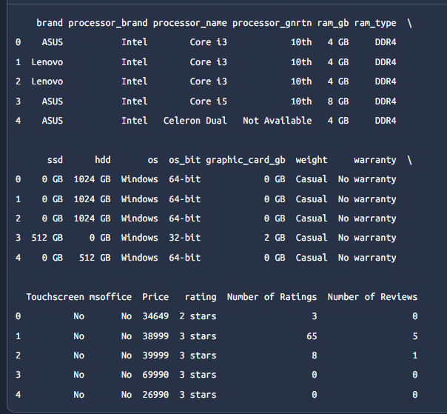

Cleaning Operating System and Rating Data
Additional columns require string parsing to extract meaningful numerical representations. The operating system bit size (os_bit) and user ratings (rating) contain text artifacts such as "-bit", " stars", and " star".
Furthermore, missing or invalid data can severely impact regression models. The processor_gnrtn column contains valid generations (e.g., "10th") as well as "Not Available" entries. A standard approach is to substitute these missing string values with a neutral numerical representation, such as "0", before converting the column to an integer type.
Task
Extract numeric data from the remaining string-based columns. To prevent errors if the code is executed multiple times, cast each column to a string first:
- Convert os_bit to string using .astype(str), replace "-bit" with an empty string, and convert it to int.
- Convert rating to string using .astype(str), chain two .str.replace() methods to remove both " stars" and " star", then convert it to int.
- Convert processor_gnrtn to string using .astype(str), replace "Not Available" with "0", replace "th" with an empty string, and finally convert it to int.
Here's the code for cleaning these three columns:
# Extract numeric part from os_bit, e.g. "64-bit" -> 64df['os_bit'] = df['os_bit'].astype(str).str.replace('-bit', '').astype(int)# Extract numeric rating, handling both "stars" and "star" formsdf['rating'] = ( df['rating'] .astype(str) .str.replace(' stars', '') .str.replace(' star', '') .astype(int))# Replace invalid generations with 0, then extract the numeric partdf['processor_gnrtn'] = ( df['processor_gnrtn'] .astype(str) .str.replace('Not Available', '0') .str.replace('th', '') .astype(int))
The .astype(str) cast at the start of each chain is a nice defensive touch — if you re-run the cell in a notebook, the second pass operates on already-cleaned numeric columns. Casting back to str first makes the .str accessor valid again and keeps the whole pipeline idempotent.
Two things worth noticing in the processor_gnrtn logic:
Order matters here. "Not Available" gets replaced with "0" before stripping "th". If the order were reversed, "0th" wouldn't occur anyway, but the given sequence is safe: "0" contains no "th", so it survives unchanged. Meanwhile "10th" → "10" and "Not Available" → "0".
The zero sentinel has a trade-off. Encoding missing generations as 0 works because no real generation is zero, so the value is unambiguous to the model. However, a tree-based regressor can split on generation == 0 versus generation > 0, effectively treating unknowns as their own category — which is usually fine. If you later use a linear model, you might revisit this, since the model would interpret 0 as "oldest generation" rather than "missing." Keeping processor_brand alongside it lets the model partially compensate.
Once these are done, nearly all the unit-bearing columns are numeric. Based on the original column list, what remains as object/categorical types are brand, processor_brand, processor_name, ram_type, os, weight, warranty, Touchscreen, and msoffice — which sets up the next natural step of encoding categoricals for modeling.

Exploratory Data Analysis for Price Drivers
Understanding relationships between features and the target variable is essential before proceeding to modeling. Visualizing statistical distributions aids in identifying which variables strongly drive pricing.
A correlation heatmap visualizes the linear relationships among numerical variables. Features with high absolute correlation values relative to the target variable (Price) hold significant predictive power.
Boxplots reveal how discrete numerical features, such as RAM and graphics card capacities, influence the overall price distribution. These plots visualize medians, quartiles, and outliers, providing a clear comparison across different hardware configurations.
Task
Perform exploratory data analysis using Seaborn and Matplotlib:
- Filter the DataFrame to include only numeric columns using df.select_dtypes(include='number') and assign it to numeric_df.
- Create a correlation heatmap for numeric_df using sns.heatmap() with annot=True and cmap='coolwarm'.
- Create a boxplot to display the relationship between 'ram_gb' on the x-axis and 'Price' on the y-axis using sns.boxplot().
- Create a second boxplot to display the relationship between 'graphic_card_gb' on the x-axis and 'Price' on the y-axis using sns.boxplot().

Here's the EDA code for this step:
import seaborn as snsimport matplotlib.pyplot as plt# Keep only numeric columns for correlation analysisnumeric_df = df.select_dtypes(include='number')# Correlation heatmapplt.figure(figsize=(12, 8))sns.heatmap(numeric_df.corr(), annot=True, cmap='coolwarm')plt.title('Correlation Heatmap of Numeric Features')plt.tight_layout()plt.show()# Price distribution across RAM sizesplt.figure(figsize=(10, 6))sns.boxplot(x='ram_gb', y='Price', data=df)plt.title('Price Distribution by RAM Capacity')plt.show()# Price distribution across graphics card memoryplt.figure(figsize=(10, 6))sns.boxplot(x='graphic_card_gb', y='Price', data=df)plt.title('Price Distribution by Graphics Card Memory')plt.show()
A few things to look for in the outputs:
In the heatmap, expect ram_gb, ssd/total_storage, and graphic_card_gb to show relatively strong positive correlations with Price. Watch for multicollinearity too — since you engineered total_storage from ssd and hdd, check its correlation against the originals if any are still present, and note that rating and the review/ratings counts often correlate with price as well. If two predictors are correlated near 0.95+, you may want to drop one later to reduce redundancy.
In the RAM boxplot, a clear upward trend in medians (4 GB → 8 GB → 16 GB) confirms RAM as a strong price driver. You'll likely also see widening boxes at higher RAM values — premium configurations vary more in price, and outliers at the top reflect gaming or workstation laptops.
The graphics card boxplot is interesting because most laptops share "0 GB" (integrated graphics), creating one dominant group. If the plot looks lopsided, that's expected. The contrast between the 0 GB group and the 4 GB/6 GB/8 GB groups typically shows a substantial median jump, signaling that discrete GPU presence is one of the strongest single price indicators.
One minor tip: if the boxplots render with squeezed x-axes because many RAM/GPU values are rare (e.g., a handful of 64 GB machines), passing order=df['ram_gb'].value_counts().index sorts categories by frequency and makes the plots easier to read. Once you've eyeballed these, the logical next step is encoding the categorical columns (brand, processor_name, os, etc.) before fitting the regression model.

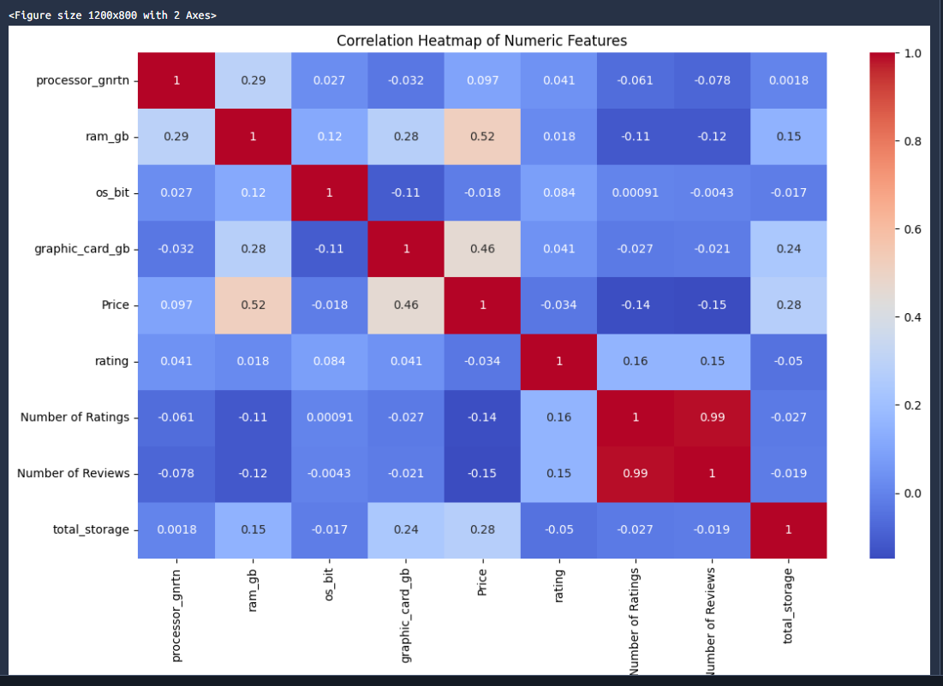
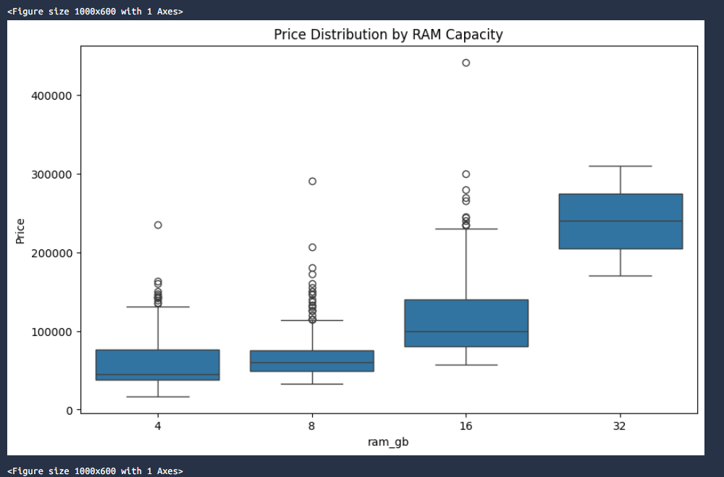
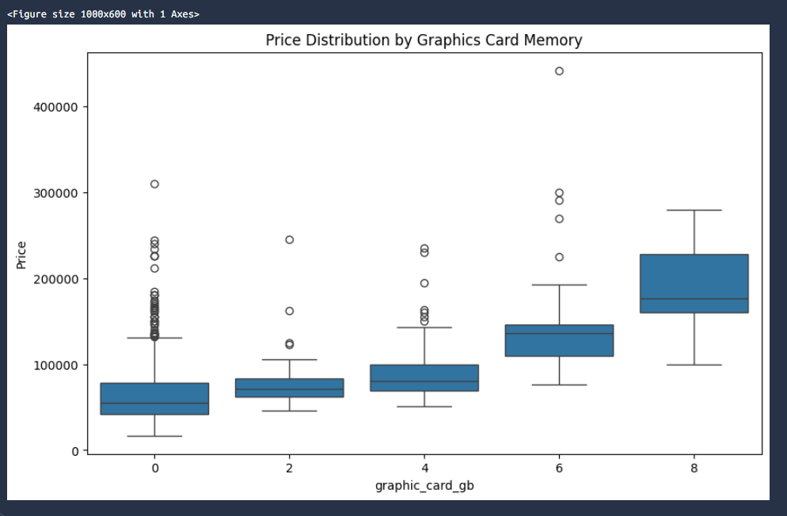

Encoding Categorical Variables and Splitting Data
Machine learning algorithms demand numerical representations. The remaining textual columns must be encoded into numerical formats without introducing mathematical biases.
Categorical variables containing fewer than five unique values are suitable for One-Hot Encoding, which creates binary indicator columns. Variables with five or more unique values are transformed using Target Encoding (replacing categories with the mean target value). This technique maintains dataset dimensionality while preserving the relationship between the category and the target variable.
Following encoding, the dataset is partitioned into training and testing subsets to validate model generalization.
Task
Encode categorical features and perform a train/test split:
- Identify categorical columns using df.select_dtypes(include=['object']).columns.
- Iterate through these columns. If a column has fewer than 5 unique values, encode it using pd.get_dummies(..., drop_first=True). Otherwise, apply target encoding by replacing the category with its mean Price using .map(df.groupby(col)['Price'].mean()).
- Define X as all columns except 'Price', and y as 'Price'.
- Split the data into X_train, X_test, y_train, and y_test using an 80/20 split and random_state=42.
Here's the code as described in the task:
from sklearn.model_selection import train_test_split# Encode categorical columnscat_cols = df.select_dtypes(include=['object']).columnsfor col in cat_cols: if df[col].nunique() < 5: # One-hot encode low-cardinality columns dummies = pd.get_dummies(df[col], prefix=col, drop_first=True) df = pd.concat([df, dummies], axis=1) df.drop(columns=[col], inplace=True) else: # Target encode high-cardinality columns df[col] = df[col].map(df.groupby(col)['Price'].mean())# Define features and targetX = df.drop(columns=['Price'])y = df['Price']# 80/20 train/test splitX_train, X_test, y_test_placeholder = None, None, None # placeholder, see belowX_train, X_test, y_train, y_test = train_test_split( X, y, test_size=0.2, random_state=42)
(Ignore that placeholder line — copy just the final train_test_split call.)
Now, an important caveat worth understanding before you move to modeling:
This target encoding leaks test information. By computing groupby(col)['Price'].mean() on the full DataFrame before splitting, the mean includes the test rows' prices. The model effectively peeks at the target for the very rows it's being evaluated on, which inflates test scores. On laptop brands and processor names this bias may be modest, but it's a real flaw. The production-grade approach computes the encoding maps on the training set only:
# Leakage-safe version: fit encoders on train, apply to bothX_temp, X_test, y_train, y_test = train_test_split( X_raw, y, test_size=0.2, random_state=42)for col in high_card_cols: means = X_temp.join(y_train).groupby(col)['Price'].mean() X_temp[col] = X_temp[col].map(means) X_test[col] = X_test[col].map(means) # unseen categories -> NaN
Note the second consequence of doing it properly: categories that appear only in the test set map to NaN and need a fallback (e.g., .fillna(y_train.mean())).
If you're following a course grader that expects the simpler version, use the first snippet — but if you care about honest generalization estimates, use the leakage-safe variant. Expect columns like brand (~dozens of brands), processor_name, and possibly os/ram_type to fall on either side of the 5-unique-values threshold; running df[cat_cols].nunique() beforehand tells you exactly which branch each column takes. Ready for the model fitting step whenever you are.

Building the Random Forest Regressor
Regression techniques estimate continuous target variables. The Random Forest Regressor operates by constructing multiple decision trees and outputting the average prediction.
This ensemble method is highly effective for pricing models because it is robust against overfitting, requires minimal hyperparameter tuning out of the box, and handles complex, non-linear relationships seamlessly.
Task
Initialize and train the regression model:
- Import RandomForestRegressor from sklearn.ensemble.
- Initialize the model as rf_model with random_state=42.
- Fit the model using the training data (X_train and y_train).
- Generate predictions on the test set (X_test) and store them in a variable named y_pred.
Here's the model building step:
from sklearn.ensemble import RandomForestRegressor# Initialize the modelrf_model = RandomForestRegressor(random_state=42)# Train on the training setrf_model.fit(X_train, y_train)# Predict on the test sety_pred = rf_model.predict(X_test)
That's all it takes to get a baseline model running. A few notes:
With default hyperparameters, sklearn uses 100 trees (n_estimators=100) and bootstrap sampling with feature subsampling at each split — that combination is exactly what makes Random Forests resilient to overfitting compared to a single decision tree. Since you set random_state=42, the results are reproducible across runs.
At this point y_pred holds the predicted prices for the 20% test set. The natural next step is evaluation — typically computing MAE, RMSE, and R² by comparing y_pred against y_test. Given that laptop prices are right-skewed (a few expensive gaming/workstation machines), don't be alarmed if MAE is a much more interpretable metric than RMSE here, since RMSE heavily penalizes large misses on those outlier laptops.
One extra diagnostic worth trying after evaluation: rf_model.feature_importances_ paired with X_train.columns reveals which engineered features (likely ram_gb, total_storage, and the target-encoded processor_name) ended up driving predictions — a nice way to confirm whether your feature engineering from earlier steps paid off. If your evaluation numbers come out surprisingly high, it's worth recalling the target-encoding leakage point from the previous step, since that's the most common cause of inflated test scores.

Evaluating Model Performance and Feature Importance
Model validation metrics quantify predictive accuracy. For regression tasks, the Mean Absolute Error (MAE) describes the average prediction error in the original currency units, while the R-squared score explains the proportion of variance captured by the model.
Beyond absolute metrics, extracting feature importances provides critical insight. This determines which hardware components – such as total storage, processor brand, or RAM – exert the most substantial influence on final laptop pricing.
Task
Evaluate the model and visualize feature importances:
- Import mean_absolute_error and r2_score from sklearn.metrics.
- Calculate both metrics using y_test and y_pred and print the results.
- Extract the feature importances from rf_model.feature_importances_.
- Identify the top 5 most important features using np.argsort() and plot them using a horizontal sns.barplot().

Here's the evaluation code:
import numpy as npfrom sklearn.metrics import mean_absolute_error, r2_score# Print validation metricsmae = mean_absolute_error(y_test, y_pred)r2 = r2_score(y_test, y_pred)print(f"MAE: {mae:.2f}")print(f"R² Score: {r2:.4f}")# Feature importances and top-5 plotimportances = rf_model.feature_importances_feature_names = X_train.columnstop_5_idx = np.argsort(importances)[-5:][::-1] # indices sorted descendingplt.figure(figsize=(10, 6))sns.barplot( x=importances[top_5_idx], y=np.array(feature_names)[top_5_idx])plt.title('Top 5 Most Important Features for Price Prediction')plt.xlabel('Feature Importance')plt.ylabel('Feature')plt.tight_layout()plt.show()
A walkthrough of the key logic:
The metrics. mean_absolute_error gives the average prediction miss in currency units — if it prints, say, 15000 and the dataset is priced in rupees, that's "predictions are off by ₹15,000 on average," which is directly interpretable. r2_score runs from 0 to 1, where 0.85 means the model captures 85% of price variance. Don't be surprised by a strong R² here; Random Forests on encoded laptop specs typically perform well.
The argsort trick. np.argsort(importances) sorts ascending, so slicing [-5:] grabs the five largest values and [::-1] flips them into descending order. Pairing indices with np.array(feature_names) is necessary because pandas Index objects don't reorder the same way with fancy indexing.
Interpreting the barplot. With sklearn's default impurity-based importances, expect target-encoded columns like processor_name to dominate — partly genuine signal, partly inflation from high cardinality (more categories mean more split opportunities, so encoded nominal features get artificially boosted). Genuine hardware drivers usually cluster around ram_gb, graphic_card_gb, and total_storage. If you want more trustworthy rankings, sklearn offers a permutation importance option that debiases this effect:
from sklearn.inspection import permutation_importanceresult = permutation_importance(rf_model, X_test, y_test, n_repeats=10, random_state=42)
It's slower but evaluates importance by actual prediction damage on held-out data rather than training split counts.
That completes the full pipeline: loading, feature engineering, cleaning, EDA, encoding, training, and evaluation. If you want, share your printed MAE/R² values and the top-5 chart results and I can help you interpret them or suggest tuning next steps (e.g., GridSearchCV over n_estimators and max_depth).

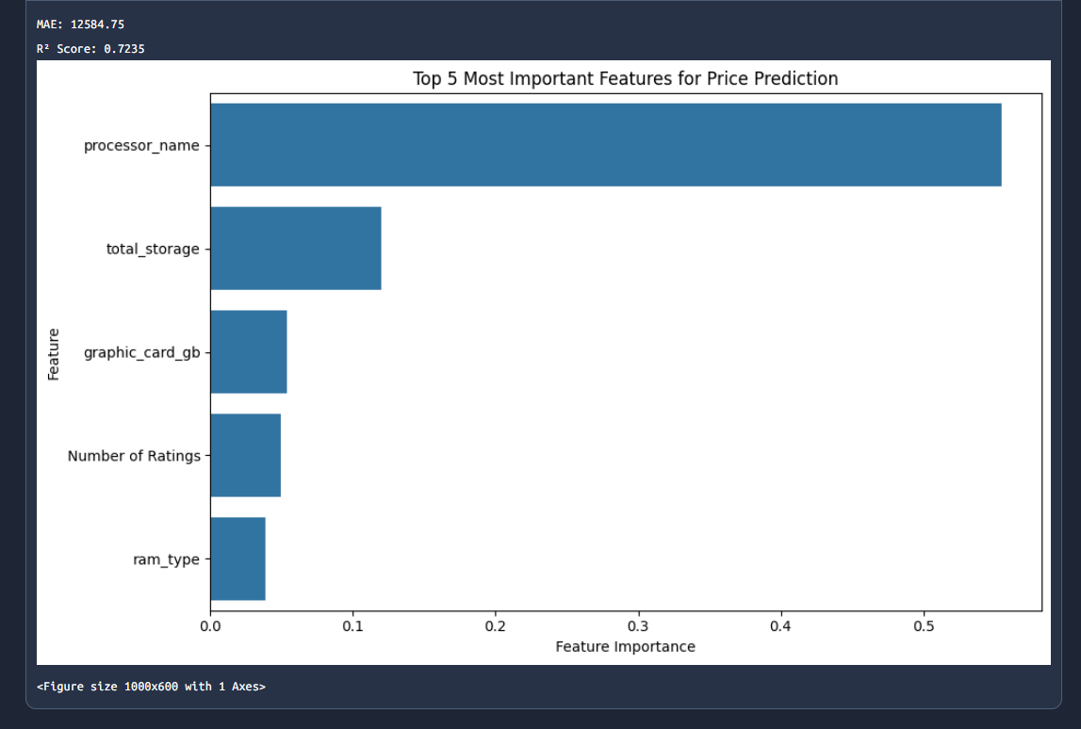

Background Theory & Checklists: Laptop Price Prediction Project

1. Background Theory Needed

A. Python & Data Manipulation Fundamentals
- Pandas core operations: loading CSVs with pd.read_csv(), inspecting with .head(), .info(), .describe(), .shape
- Data types in pandas: object/string vs. numeric dtypes, and why models require numeric inputs
- String accessors: .str.replace(), .str.extract(), .unique(), .nunique() for cleaning text values
- Column operations: creating new columns (total_storage), dropping columns (drop), arithmetic across columns
- NumPy essentials: arrays, boolean/fancy indexing, np.argsort() for sorting indices

B. Data Cleaning & Feature Engineering Concepts
- Why features need extraction: raw data stores units inside strings ("4 GB", "64-bit", "3 stars"); models can't compute on text
- Idempotency: the .astype(str) pre-cast trick that lets cleaning code run safely multiple times
- Missing data strategies: sentinel values (encoding "Not Available" as 0), when zero-meaningful vs. zero-as-missing matters
- Dimensionality reduction via feature construction: combining ssd + hdd into total_storage
- Target leakage: why computing encodings or statistics using data that belongs in the test set inflates evaluation scores

C. Exploratory Data Analysis (EDA)
- Correlation analysis: Pearson correlation coefficients, reading heatmaps, multicollinearity between features
- Distributional thinking: boxplots (median, quartiles, IQR, outliers), right-skewed price distributions
- Feature–target relationships: visually identifying price drivers before modeling

D. Encoding Categorical Variables
- One-Hot Encoding: binary indicator columns for low-cardinality features; drop_first=True and the dummy variable trap
- Target (mean) Encoding: replacing categories with their mean target value; pros (preserves dimensionality) and cons (leakage risk, overfitting on rare categories)
- Cardinality-based strategy selection: the <5 / ≥5 unique values decision rule

E. Machine Learning Fundamentals
- Supised regression: predicting continuous targets vs. classification
- Train/test splitting: 80/20 partition, random_state for reproducibility, purpose of held-out evaluation
- Decision trees: splitting on feature thresholds, impurity (Gini/MSE for regression), overfitting tendency
- Random Forests: bootstrap aggregating (bagging), feature subsampling at splits, averaging across trees, why ensembles resist overfitting
- Hyperparameters: n_estimators, max_depth, and their bias-variance trade-offs

F. Model Evaluation
- MAE: average absolute error in original units; robust to outliers, easy to interpret
- RMSE: penalizes large errors more; behavior on skewed price data
- R²: proportion of variance explained; interpretation range
- Feature importance: impurity-based (feature_importances_) vs. permutation importance; why high-cardinality features get inflated importance
- Bias–variance trade-off: diagnosing underfitting vs. overfitting from train vs. test metrics

2. Project Completion Checklist

Step 1 — Load & Inspect
- Import pandas as pd
- Load laptop_price.csv into df
- Print df.head()
- Run df.info() and identify object-typed columns that should be numeric
- Check df.columns for spacing/underscore inconsistencies
- Scan for nulls and disguised missing values ("No", "Not Available", "0 GB")

Step 2 — Memory & Storage Features
- Loop over ['ram_gb', 'ssd', 'hdd', 'graphic_card_gb']
- Apply .str.replace(' GB', '') then .astype(int)
- Create total_storage = ssd + hdd
- Drop original ssd and hdd columns
- Verify with df[['ram_gb', 'total_storage']].head()

Step 3 — OS, Rating & Generation Cleaning
- Clean os_bit: .astype(str) → replace('-bit') → astype(int)
- Clean rating: .astype(str) → replace(' stars') → replace(' star') → astype(int)
- Clean processor_gnrtn: .astype(str) → replace('Not Available', '0') → replace('th') → astype(int)
- Confirm no ValueError from unexpected string values (unique() check)

Step 4 — EDA
- Create numeric_df via select_dtypes(include='number')
- Plot correlation heatmap (annot=True)
- Identify features with highest |correlation| to Price
- Boxplot ram_gb vs Price
- Boxplot graphic_card_gb vs Price
- Note multicollinearity candidates and expected price-driver behavior

Step 5 — Encoding & Splitting
- List object columns via select_dtypes
- Per column: <5 unique values → one-hot with drop_first=True; ≥5 → target-encode via groupby[col]['Price'].mean()
- Define X = df.drop('Price'), y = df['Price']
- Split 80/20 with random_state=42
- (Stretch goal) Refactor target encoding to fit on train only, fill unseen test categories with training mean

Step 6 — Model
- Import RandomForestRegressor, initialize with random_state=42
- Fit on X_train, y_train
- Predict on X_test → y_pred

Step 7 — Evaluation
- Compute and print MAE and R²
- Extract rf_model.feature_importances_
- Select top 5 via np.argsort()
- Plot horizontal bar chart of top features
- Interpret results: which hardware components drive price?

3. Transferable Checklist for Similar Projects

Phase 1 — Understand the Problem
- Define the target variable and task type (regression vs. classification)
- Identify the metric(s) that matter to stakeholders (currency units? percentage?)
- Understand the domain (what drives laptop prices drives car/house insurance differently)

Phase 2 — Data Acquisition & Audit
- Load data; check shape, dtypes, nulls, duplicates
- Build a dtype audit table: expected type vs. actual type per column
- List every column needing unit/artifact stripping
- Identify sentinel values and disguised missing data

Phase 3 — Feature Engineering
- Convert unit-bearing strings to numerics (always idempotent: .astype(str) first)
- Decide: impute, sentinel, or drop missing values — justify each choice
- Engineer composite features (sums, ratios, flags) where domain logic suggests
- Document every transformation for reproducibility

Phase 4 — EDA
- Correlation heatmap on numeric subset
- Univariate distributions of target (expect skew with prices)
- Categorical feature vs. target plots (boxplots/violins)
- Check for leakage-prone columns (anything derived from the target)

Phase 5 — Encoding & Splitting
- Partition categorical columns by cardinality (rule: ~5 unique values threshold)
- Low cardinality → one-hot; high cardinality → target/frequency encoding (fit on train only!)
- Handle unseen categories at inference (fallback to training mean)
- Split before any target-dependent computation
- Fix random_state everywhere for reproducibility

Phase 6 — Modeling
- Start with a baseline (mean predictor or linear regression) for comparison
- Fit Random Forest with defaults as first serious model
- Compare train vs. test metrics to detect over/underfitting

Phase 7 — Evaluation & Interpretation
- Report MAE, RMSE, and R² together (each reveals something different)
- Plot predicted vs. actual values for residual diagnostics
- Feature importance via feature_importances_ AND permutation importance
- Sanity-check top features against domain intuition

Phase 8 — Iterate & Communicate
- Hyperparameter tuning (GridSearchCV/RandomizedSearchCV)
- Cross-validation for robust estimates (cross_val_score)
- Compare alternative models (Gradient Boosting, XGBoost)
- Summarize findings for non-technical audiences

4. Common Pitfalls Checklist
- Data leakage: encoding/scaling computed on full dataset instead of train only
- Non-idempotent cleaning: rerunning cells breaks on already-cleaned columns
- Hidden strings: values like "Not Available" or "No" breaking .astype(int)
- Impurity-importance bias: trusting feature_importances_ for high-cardinality encoded features
- Overreliance on R²: it hides error magnitude; always pair with MAE/RMSE
- Untracked randomness: forgetting random_state so results aren't reproducible
- Treating leakage-inflated scores as genuine skill: suspiciously high test R² deserves suspicion first

If you'd like, I can turn the theory section into a prioritized study roadmap (e.g., what to learn first if you're new to scikit-learn), or expand any single section — like leakage prevention or encoding strategies — into a deeper mini-guide.

